

**DIPLOMA IN SOFTWARE ENGINEERING**

**DEPARTMENT OF INFORMATION AND COMMUNICATIONS TECHNOLOGY**

**INDUSTRIAL ATTACHMENT REPORT**

**AT**

**THE NATIONAL TREASURY STATE DEPARTMENT OF PLANNING**

**BY**

**ANDREW BADA KOMORA**

**DSE-01-0136/2019**

# DECLARATION

This is to declare that this attachment report is my original work that has not been presented to any other university or institution of higher learning.

Signed……………………………………………………….

Date: 4th AUGUST, 2021.

NAME: ANDREW BADA KOMORA.

REG NO: DSE-01-0136/2019.

## UNIVERSITY SUPERVISOR

This is to declare that this attachment report has been submitted for examination with my approval as the Zetech University supervisor to the student.

Signature……………………………………………………….

Date: 4th AUGUST, 2021.

NAME OF UNIVERSITY SUPERVISOR: SIMON CHEGE.

## INDUSTRY SUPERVISOR

Director of ICT department, State Department of planning

Contact: 0723372595

NAME OF INDUSTRY SUPERVISOR: MADAM FRIDAH MIRITI

# ACKNOWLEDGEMENT

This attachment would not have been successful without the sacrifices, cooperation and support from a number of people who enabled me to gain a lot of knowledge, perspective, wisdom, aspects from the industrial attachment and work-life routine.

First, I would like to appreciate the almighty God for His mercy and grace to open a door for me to find and complete my attachment and guiding me in through this period.

I wish to acknowledge the entire National Treasury State department of planning, ICT and PIM department fraternity for guiding and supporting me to gain experience in several fields and making the working environment conducive and friendly.

Finally, I would like to thank my parents for their support throughout the entire period of my attachment. Thank you.

# EXECUTIVE SUMMARY

This report is compiled in partial fulfillment of Diploma in software Engineering (DSE) at Zetech University and it serves to provide an overview of what I learned during the attachment period at THE STATE DEPARTMENT OF PLANNING. The sources used in writing this report includes; observations of underwriting materials that has been carried out by the company and reading from the internet. The report gives a brief description of the history of the company and the functions performed. The organization’s hierarchy chart and a brief introduction of the departments where I was attached is outlined, the duties that were assigned to me and the knowledge and skills that were acquired in detail and the evaluation of the organization and recommendations for the future of the government organization.

**Table of Cossntents**

DECLARATION 2

ACKNOWLEDGEMENT 3

EXECUTIVE SUMMARY 4

CHAPTER ONE 6

1.0 Introduction 6

1.1 Purpose 6

CHAPTER TWO 7

2.0 STATE DEPARTMENT OF PLANNING HISTORY 7

2.1 Organization Structure 7

2.2 SWOT Analysis 8

CHAPTER THREE 9

3.0 Significance of the attachment 9

3.1 Description of duties 9

3.2 Skills attained 10

3.3 Challenges encountered during the attachment 10

3.4 Recommendations 10

3.5 Strength of the attachment 11

3.6 Conclusion. 11

# CHAPTER ONE

# 1.0 Introduction

Every student of Zetech University undertaking any course is required to undergo an industrial attachment in a field relevant to their course of study. It is essential for award of any undergraduate. The attachment is under supervision and intensive report compilation required to be submitted to the university on completion.

# 1.1 Purpose

The report serves to summarize the activities and experience with Executive residency. The following are the purpose of the program:

* To output the knowledge and skills acquired in classroom to a working environment.
* To translate the theories and assignments learnt in class into an actual working environment.
* To assess interest of the learner in occupations he/she intends to undertake.
* To expose the learner to work methods not learned in class and to provide access of equipment and devices that are not available at the university.

# CHAPTER TWO

# 2.0 STATE DEPARTMENT OF PLANNING HISTORY

The planning function in Kenya dates back to the pre-independence period and can be traced to the Oliver Lyttleton Constitution of 1954, when the Ministry of Finance and Development was created. On attainment of independence in December 1963, the Ministry of Economic Planning and Development was created to spearhead development planning in Kenya. It had three divisions that included: Administration, Statistics, and Planning. Over the years, the planning obligation has been executed either in a fully-fledged Ministry or in a division of the Ministry responsible for Finance and Planning. In 2013, Planning became a State Department under the Ministry of Devolution and Planning and in 2017, it was moved to The National Treasury and Planning.

# 2.1 Organization Structure

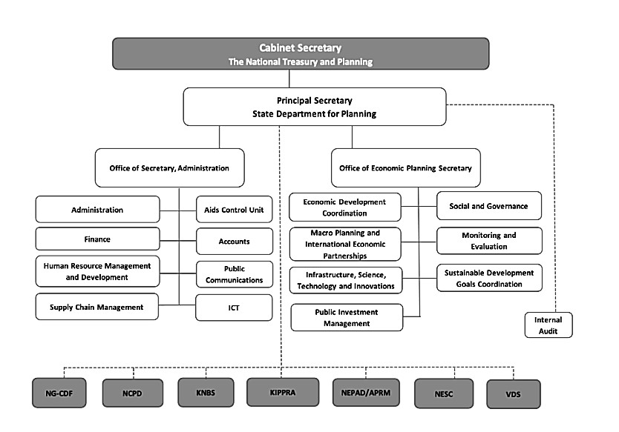

# 2.2 SWOT Analysis

## Strengths

* Presence of experienced personnel who show you the ropes in the organization.
* Unlimited resources in the basis of the department.
* Presence of opportunities to learn and research more.
* Flexibility in terms of working hours, considering the pandemic.
* The leadership (directors) are appreciative of your help and are willing to offer a hand or advice towards a task or suggestion.

## Weakness

* Partial network difficulties.
* Less knowledge of advanced technology.
* Outdated computer systems.
* Slow decision making especially during making requests.
* Less internet infrastructures.

## Opportunities

* Source of great experience from the working environment and interactions.
* Contracts in delivery of services such as meals and parcels.

## Threats

* Lack of unity in terms of agreements and decision making.
* Being infected by the Covid 19 virus due to the personnel traffic in the office and building at large.
* Being misunderstood by outsiders, maybe due to misinterpretation of information.
* Lack of individual confidentiality and/ or leaking of false information.

# CHAPTER THREE

# 3.0 Significance of the attachment

* It has helped me to assess the occupation of the career that I plan to specialize in future.
* It has helped in being bold and confident while talking to a group of people.
* The program has given me an opportunity to express myself especially in consulting and contributing in departmental meetings.
* It has assisted me to acquire a real-world experience of a public sector worker.
* It has allowed me to network with a variety of personnel and learn from them.

# 3.1 Description of duties

**Hardware**

* Setting up and assembling computers to new locations.
* Replacing faulty peripherals e.g., UPS, CPU, access points • Configuring Ethernet cables connections.
* Replacing cartridges on printers.
* Fixing paper jams in printers.
* Setting up meetings, starting projectors and applying connections with other devices.

## Computer operations

* Data recovery and backup.
* Troubleshooting of computer systems.
* Worked on a web application as an assignment from madam Fridah Miriti and Mr Paul Kibera.

## Networking

* Identifying problems in the network for example loose cables.
* Troubleshooting the problems of network cables and setups.
* Collaboration in configuration of the department’s internet connection.

**Business and data analysis**

Data entry and data analysis

# 3.2 Skills attained

* Good rapport and confidence in communication with staff and visitors.
* How to be responsible and discipline.
* Importance of team work and cooperation.
* Knowledge on printers, dot matrix and laser printers and their functionalities.
* How to solve problems that are personnel based and teaching them the solutions and causes of the problems.
* Operating scanners and projectors.
* Professional data entry skills.

# 3.3 Challenges encountered during the attachment

* Cost- travelling to project areas was so expensive.
* There some staff who are still technophobic as they are not ready to embrace ICT.
* Elevators not working; hence one has to take a long stair case walk to the office.
* At times, lack of internet.
* Taking care of oneself especially hygienically due to the Covid 19 pandemic.

# 3.4 Recommendations

I recommend that:

* The organization to offer in-house training to the computer technophobic staffs.
* The attaches to be given some form of monetary incentives so as to boost their morale.
* The organization to increase the number of computers in the organization.
* The organization to provide more working software and tools to ease operation.

# 3.5 Strength of the attachment

* The employees are willing to be assisted and taught if they get stuck.
* The diligence of the employees is of high quality which enables them to perform efficiently.
* I had a good chance to compare both the theoretical and practical perspective of both business and IT.
* I had a good platform with adequate resources to conduct my personal attachment projects.

# 3.6 Conclusion.

In conclusion I would like to appreciate Prof. Joyce Gikandi, Mr. Elijah Kinaro, Mr. Paul Kibera and Ms. Gladys Gathera who were my immediate advicers for their continued support, patience and advices during my attachment period. They were of great help and pillar to my growth during my attachment period. I also appreciate the organization, my colleagues, Warren Gakuo and the others and the staffs in general for giving me a conducive environment to learn and implement my knowledge to solve their problems.

I would also like to take this opportunity to thank Zetech University fraternity where I undertook my course until the final year for equipping me with industrial skills and knowledge.

The attachment contributed a lot in my career for equipping me with new skills to giving me work experience, despite several challenges that I came across during the period, the attachment has played a fundamental role to my career and personal growth. I can proudly say that I have gained skills, experience and knowledge in both information technology and business.